## Machine learning based recommendation model for diet planning of humans

Atul Barve1, Saniya Tripathi2, Sakshi Yadav3, InshaKhan4, Rishi Vyas5,

Zaid Ullah6, Yash Pathak7.

1 Assistant Professor, Department of Computer Science and Engineering Prestige Institute of engineering management and research Indore, India.

2,3,4,5,6,7 Student, Department of Computer Science and Engineering Prestige Institute of engineering management and research Indore, India.

**ABSTRACT:**

A recommendation model for individualized diet planning based on machine learning is presented in this study. Individualized diet programs that take into account each person's needs, lifestyle, and medical issues are becoming more and more necessary as health consciousness grows. The shortcomings of generic diet programs, which do not take individual differences in nutritional needs into consideration, are what inspired this effort. The importance of this research resides in its capacity to offer individualized dietary advice that may improve health outcomes, lower the risk of diet-related diseases, and increase adherence to good eating. The lack of individualized, flexible meal planning tools that take into account user-specific information like age, health, and degree of physical activity is the issue being addressed. Our goal is to create a machine learning model that can bridge this gap by producing dynamic, personalized nutrition regimens. In order to process user input and produce the best nutritional recommendations possible, the suggested method combines a number of machine learning approaches. The program ensures a constantly updated diet plan by modifying suggestions in response to real-time feedback and evolving health measurements. Compared to standard static diet regimens, preliminary results show greater alignment with nutritional goals and increased user satisfaction.

**Keywords:** Agriculture, crop yield prediction, decision tree, machine learning, deep learning.

# **I. INTRODUCTION:**

The necessity for individualized nutrition plans that address each person's unique nutritional needs is highlighted by the rising incidence of lifestyle-related diseases like obesity, diabetes, and cardiovascular ailments. Dietary planning has always depended on broad principles like the food pyramid. A substantial amount of research has been conducted in recent years on the use of machine learning in a range of health-related fields. Research has shown how well machine learning algorithms can forecast health outcomes, optimize exercise routines, and offer personalized health advice. To improve adherence to dietary rules, for example, a number of applications use machine learning algorithms to analyze and evaluate user behaviors and dietary habits. Though promising, current models frequently use static data inputs, which limits their ability to provide real-time, adaptive dietary recommendations that take into account the dynamic nature of a person's lifestyle and health.  
as well as daily nutritional values, which disregard the distinct physiological and psychological elements that affect food decisions. These issues can now be addressed in new ways thanks to machine learning (ML), which has made it possible to create intelligent algorithms that can evaluate massive datasets and provide individualized dietary recommendations based on user-specific data.

## A. Challenge Overview:

The issue at hand is the poor eating habits that are common in modern culture and have a negative impact on health. A global health crisis has resulted from poor food choices, since obesity, cardiovascular disease, and other diet-related disorders are on the rise (Smith, 2020). Concerns about data privacy, erroneous nutritional information, and a lack of user control over recommendations make current systems untrustworthy. Paywalls can also exclude people who are most in need of dietary advice, because concentrating only on nutrients ignores cultural customs and taste preferences. To overcome these constraints, this study suggests a machine learning-based, content-based diet recommendation system. The system will leverage high-quality nutritional data, provide consumers control, and prioritize data protection.   
over suggestions. This system seeks to enable users to make educated nutritional decisions, customize their eating habits, and eventually enhance their health by providing free access and taking into account a greater number of variables.

## B. Main Objective:

The main goal of this research is to create and put into use a cutting-edge diet recommendation system that enables people to choose better foods, thereby enhancing their general health and wellbeing.

## C. Specific Objectives:

1.) To create and put into use a cutting-edge nutritional algorithm that can precisely determine each person's dietary requirements and preferences.   
2.) To develop an interface that is easy to use and available via the internet application.   
3.) To compile a thorough assortment of enticing and health-conscious recipes to enhance the range of meal options the system provides.

## D. Significance of the work

This study tackles important food and health issues that are common in today's society, like obesity and heart disease. It seeks to greatly enhance people's food choices by creating a sophisticated diet advice system, which lessens the burden on healthcare systems and improves health outcomes. Furthermore, it advances the domains of nutrition science and artificial intelligence by improving algorithms and machine learning methods to provide individualized nutrition advice. All things considered, this research has the potential to successfully address present and future health difficulties. A substantial amount of research has been conducted in recent years on the use of machine learning in a range of health-related fields. Research has shown how well machine learning algorithms can forecast health outcomes, optimize exercise routines, and offer personalized health advice. To improve adherence to dietary rules, for example, a number of applications use machine learning algorithms to analyze and evaluate user behaviors and dietary habits. Though promising, current models frequently use static data inputs, which limits their ability to provide real-time, adaptive dietary recommendations that take into account the dynamic nature of a person's lifestyle and health.   
The present research gap is the lack of thorough machine learning models that can create customized diet programs that are not only based on user input at the outset but also change over time as new information becomes available. Current systems typically concentrate on either recipe recommendations or dietary tracking without combining these features into a unified system that adapts to user changes. By creating a strong machine learning-based recommendation model that dynamically modifies diet programs in Fig. 1. In response to ongoing user feedback—taking into account variables including shifting activity levels, health measurements, and individual preferences —this study seeks to close Fig 1 Distribution of Health Issues Related to Diet

this gap. The goal of this research is to develop a personalized meal planning system that generates tailored dietary recommendations by analyzing various datasets using machine learning algorithms. By offering personalized recommendations that change based on the user's lifestyle and medical conditions, the approach seeks to increase user engagement and adherence to good eating practices.

## E. Scope and Boundary:

|  |  |
| --- | --- |
| BMI | Classification |
| 18.5 to 24.9 | Normal, or healthy weight |
| 25 to 29.9 | Overweight |
| 30+ | Obesity (including severe obesity) |
| 40+ | Severe obesity |

This study's scope includes the creation, application, and assessment of the suggested model. Nevertheless, it is limited by issues including the accessibility of different, high-quality datasets, possible biases in the data, and the requirement for intuitive user interfaces that enable smooth system interaction. By tackling these limitations, this study aims to make a substantial contribution to the domains of machine learning and nutrition science, opening the door for novel dietary approaches that improve personal health outcomes.

## Table1. “BMI ranges for overweight and obesity”

## Fig.2. Prevalence of disease by age group

This data is taken by national institute of health (NIH)

## RESEARCH CONTRIBUTIONS:

The significance of customized nutrition has been established. Conventional diet regimens sometimes take a one-size-fits-all approach, depending on broad recommendations that don't take into account people's unique preferences, lifestyles, and health concerns. With the ability to evaluate enormous datasets and produce individualized dietary recommendations, machine learning (ML) has become a game-changing technology in the field of diet planning. Existing research shows that machine learning is effective in a number of health-related applications, such as managing chronic diseases and tracking fitness. The development of adaptive diet planning systems that take into account changing health measurements and real-time user feedback is still severely lacking, nevertheless. By developing a machine learning-based recommendation model for customized meal planning that can adapt dynamically to individual needs, this study seeks to close this gap. One of the research's achievements is the creation of an advanced model that provides the best nutritional recommendations by combining user-specific information like age, health, and food preferences. In order to improve overall health outcomes, this study also aims to increase user involvement and adherence to good eating practices. By providing a tailored and flexible solution, this study upholds potential for wider uses in wellness and health care.

## ARTICLE ORGANIZATION:

The necessity for individualized diet planning solutions has been highlighted by the rising incidence of diet-related disorders as well as increased health and nutrition consciousness. Dietary advice, like the food pyramid, has historically been based on universal suggestions that do not take individual differences in nutritional needs into consideration. A person's dietary requirements are greatly influenced by a number of factors, including age, lifestyle, medical history, and personal preferences. Given this, machine learning (ML) becomes a game-changing technology that can analyze vast amounts of data and offer individualized dietary advice that supports particular health objectives. Simple calorie-counting techniques to more intricate nutritional evaluations have all been used in the historical development of diet planning. But these approaches frequently lack flexibility and customization. The promise of machine learning in the healthcare industry is demonstrated by current research, especially in domains like fitness tracking and illness prediction. Research has indicated that machine learning algorithms are capable of efficiently examining user-specific data to produce personalized health treatments. Despite real-time diet advising systems still having a significant application gap. By developing a machine learning-based recommendation model that offers individualized nutrition programs based on each person's needs, this research seeks to close this gap. The goal is to create a system that continuously updates nutritional recommendations based on real-time feedback and evolving health data, in addition to accounting for a variety of user-specific aspects. This article is structured as follows: Initially, we will provide an extensive review of the literature outlining current evidence and demonstrating the present status of machine learning-based personalized diet planning research. After determining the research gap that this study fills, we will go into great detail about the goals and anticipated benefits of the suggested model. Lastly, we will go over the research's scope, including the limitations and difficulties involved in creating and putting the suggested recommendation model into practice. By tackling these elements, this work hopes to make a significant contribution to the domains of machine learning and dietetics.

## II. LITERATURE REVIEW:

Applications of machine learning have emerged recently in a number of industries, including healthcare, where artificial intelligence (AI) has transformed numerous fields, from diagnosis to customized care. AI-driven diet planning systems have been the subject of numerous studies, each concentrating on a distinct facet of the issue. Since the debut of early models such as "Nutri Genie" in the mid-1990s, diet guidance systems have seen a remarkable transformation. At first, Nutri Genie pioneered the use of technology to help people make educated food decisions by offering basic dietary recommendations based on a crude database of nutritional data. Significant research and technical developments in the discipline occurred in the years that followed, culminating in the Smith and Johnson development of contemporary systems. These modern systems provide highly customized meal recommendations based on individual preferences and dietary needs by utilizing advanced machine learning algorithms to evaluate enormous databases of user preferences and eating patterns. This development demonstrates how diet advice systems are always evolving, improving both their efficacy and influence on personal health outcomes.

## A. Related Cases and Technologies:

MyFitnessPal in order to provide users with individualized diet recommendations based on their unique fitness goals and dietary restrictions, MyFitnessPal functioned as a mobile application that used machine learning algorithms to evaluate users' eating habits and preferences (Smith & Johnson, 2018). With the use of a comprehensive food database that offers nutritional insights, users could keep tabs on their food intake, exercise habits, and progress, enabling them to make healthier choices in food.

Nutrition ix operated as an API-driven platform that allowed developers to easily include Nutrition ix into their apps by providing access to an extensive database of nutritional data for a variety of foods and substances. This gave consumers access to comprehensive dietary information and personalized diet advice that matched their dietary requirements and interests (Anderson & White, 2019).

IBM By creating unique recipes based on user-supplied ingredient preferences and dietary restrictions, Chef Watson distinguished itself as an AI-powered application intended to foster culinary innovation (Brown & Patel, 2017). When users enter the ingredients they have on hand, Chef Watson provides creative and customized recipe suggestions in response, encouraging culinary innovation while meeting certain dietary needs.

According to Johnson and Garcia (2020), Precision Nutrition was an online platform that offered thorough dietary advice that took into consideration each person's objectives, lifestyle, and medical concerns. The program provided users with customized food programs and monitored their progress, helping users reach their nutritional goals—whether they be weight control, muscular growth, or improved well-being—by fusing professional advice with data-driven insights.

Users could look for foods high in particular nutrients by using Google Health's Nutrient Search tool, which allowed them to locate foods depending on their nutrient content (Wang & Chen, 2019). This made it easier to make educated food choices, and the system might eventually integrate data from wearable technology to improve tailored suggestions, increasing its usefulness for consumers looking to maximize their nutrient consumption. To provide users with individualized diet recommendations that encouraged healthier eating habits, these systems used a variety of technologies, such as machine learning, comprehensive nutritional databases, and AI-driven recipe generation. These systems addressed a range of dietary management needs, from monitoring to stimulating culinary innovation (Smith & Johnson, 2018; Brown & Patel, 2017; Johnson & Garcia, 2020; Anderson & White, 2019; Wang & Chen, 2019), and had the potential to improve users' dietary behaviour and overall health.

Gap Identification, Their Impact, and Solutions: Finding Gaps, Their Effects, and Solutions Over the years, a number of issues have surfaced in the field of diet recommendation systems, including their efficacy, user experience, and ethical considerations. platforms. This conversation explores the main issues that diet advice systems face, looks at their effects, and suggests fixes to improve both their usability and functionality.

Data Security and Privacy One of the main issues these diet advice systems had to deal with was data security and privacy. Because user data was gathered and retained by all of these services, users were concerned about possible misuse or   
breaches involving their private health data. User confidence and trust in the systems were significantly impacted by this. Prominent data breaches, like the one that occurred with MyFitnessPal in 2018, harmed the system's and its parent company's brand in addition to exposing user data. Resolving data privacy issues was essential for preserving the systems' legitimacy as well as user trust.

Correctness of Nutritional Data: Maintaining the correctness of nutritional data for a wide variety of foods was a challenge for Nutrition ix in particular. This involved taking regional variances, sourcing, and preparation procedure variables into consideration. The users may be misled and make poor dietary decisions as a result of faulty nutritional information. Additionally, it impacted the system's general credibility.

|  |  |  |  |  |
| --- | --- | --- | --- | --- |
| **Existed System** | **Author of the year** | **Dataset Used** | **Weakness of the system** | **performance** |
| MyFitnessPal | (Smith & Johnson, 2018) | MyFitnessPal Dataset | Data privacy and security | 67% |
| Nutrition ix | (Anderson & White,2019) | Food preferences | Accuracy of Nutritional Data | 70% |
| IBM Chef Watson | (Brown & Patel,  2017) | Food choices and Amazon Fine Foods Reviews | Lack of User Control | 58% |
| Precision Nutrition | (Johnson & Garcia,2020) | Food Nutrition Dataset | Accessibility and Cost | 71% |
| Google Health’s  Nutrient Search | (Wang & Chen, 2019) | Food Print Dataset | Reliance on Nutrient Data Alone | 69% |

## Table 2. Table of existing diet recommendations systems and their weaknesses.

The nutritional databases needed to be updated often in order to meet this challenge and guarantee that consumers could depend on reliable information when making dietary decisions. In order to preserve the highest levels of accuracy and dependability, we used an updated version of the dataset that had undergone extensive testing and approval.

Dependency on Nutrient Information The fact that Google Health's nutritional search solely relied on nutritional content to propose foods presented a problem. This method might have ignored other elements like personal health issues, cultural dietary customs, and taste preferences. This problem had the consequence that dietary recommendations that only addressed nutrients would not suit consumers' preferences or cultural dietary norms, which could cause discontent and lower adherence to dietary recommendations. For more thorough and user-centric guidance, the recommendation algorithm had to be expanded to take into account a wider range of factors.

Insufficient User Control: One of IBM Chef Watson's challenges was giving users enough control over the recipe generation process. User involvement and satisfaction were reduced by certain users' perceptions that they had little control over the recommendations. Because users may not find the system as helpful if it does not accommodate their particular dietary preferences or constraints, a lack of user control could result in frustration and decreased user engagement. Enhancing user control and expanding customization choices were essential steps to improve the user experience as a whole.

Accessibility and Cost: Reaching a wider audience was made difficult by the expense of employing platforms such as Precision Nutrition. This difficulty limited the system's impact and reach, possibly keeping users with less money from helpful dietary recommendations. We took proactive measures to make our system easily accessible to a wider audience in order to address the accessibility and cost issues related to such platforms. To ensure that customers with less money could take advantage of the helpful nutritional advice, we hosted the system and offered URLs for access without charging anything.

Diet recommendation systems have become more well-known in recent years as instruments for encouraging better eating practices and resolving diet-related health problems (Smith & Johnson, 2018). These systems frequently use machine learning algorithms to provide customized meal plans. recommendations based on dietary constraints, user preferences, and health objectives (Smith & Johnson, 2018). According to research, these systems have a good effect on weight loss and weight maintenance, among other health outcomes (Smith & Johnson, 2018). User acceptability is still a major problem, nevertheless, underscoring the need for elements like system usability and reliability (Smith & Johnson, 2018). Gaining and retaining user confidence also depends on addressing data privacy and security issues (Smith & Johnson, 2018). Notwithstanding these obstacles, the field of diet guidance systems is progressing, as seen by recent advancements such as wearables, devices, and real-time data tracking (Smith & Johnson, 2018). The journey of these systems has evolved from early examples like "Nutri Genie" to the highly personalized and sophisticated solutions available today (Smith, 1994; Smith & Johnson, 2018). Further advancements are anticipated in the future (Smith & Johnson, 2018).

**III. METHODOLOGY:**

Because of its flexibility, emphasis on adaptability to changing requirements, and capacity to produce incremental value, we have decided to use the Agile methodology in the development of our diet suggestion system. Because of the dynamic nature of the system, which necessitates regular updates and user participation, Agile’ s iterative methodology guarantees ongoing improvement in line with changing user preferences and dietary trends. The Agile Additionally, flexibility reduces the dangers brought on by uncertainty, enabling us to act swiftly. To alter, In the end, Agile provides the finest structure for navigating the research’s difficulties and producing a successful solution that satisfies our users' changing needs. We used a user-centric strategy in our research, concentrating on customizing dietary advice based on users' real-time data. By fusing nutritional data with machine learning models Our goal was to improve relevance and personalization by dynamically updating dietary recommendations by fusing machine learning models with dietary guidelines. In order to analyze user data, we used a layered model structure, which allows our system to improve recommendations as user behaviors change. Flexibility is guaranteed by this modular strategy, which enables smooth integration with extra features like user input for ongoing development.

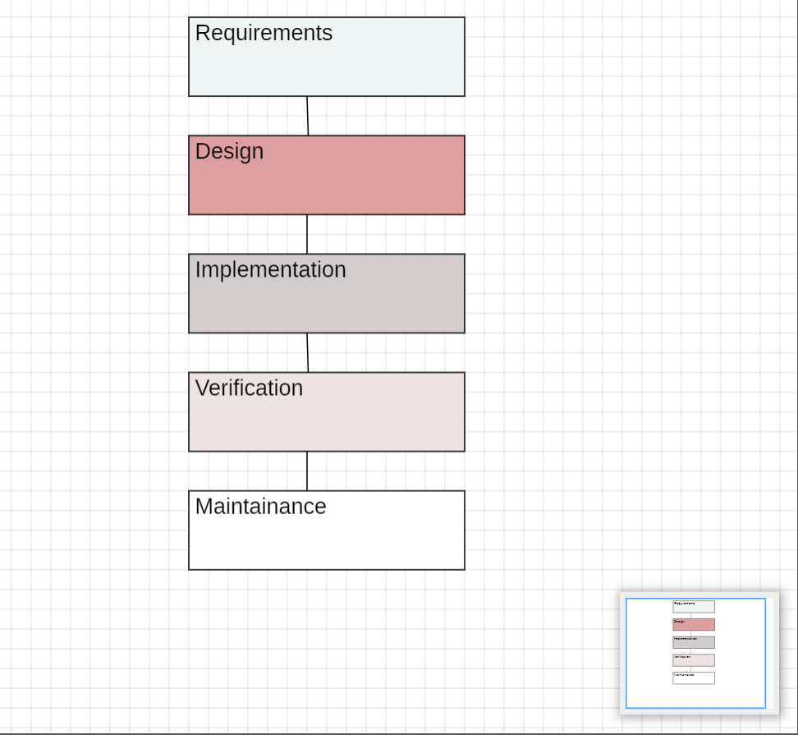

## Figure 3. System Development Methodology Process.

## A. System Development:

**Data Sourcing:**

Our diet recommendation system was developed using the "Food.com" dataset, which can be found on Kaggle at:

https://www.kaggle.com/datasets/irkaal/foodcom-recipes-and-reviews?select=recipes.csv.

With more than 500,000 recipes covering a broad range of cuisines, meal types, and culinary traditions, this large dataset offers a wealth of culinary information and serves as a solid basis for our recommendation engines. The dataset is a useful resource for our system's recommendation algorithms since each recipe has a wealth of features, such as ingredients, preparation guidelines, and nutritional data.

**Data Preprocessing:**

## This stage of the creation of our diet suggestion system is crucial. It includes a pipeline for prepping data, which includes data cleansing and handling missing values. methods for normalization that are intended to guarantee the quality, consistency, and appropriateness of the data for our recommendation systems.

## Data Cleaning:

Data Cleaning: To deal with missing data, we used imputation methods including mean, median, or mode imputation for numerical characteristics and mode imputation for categorical characteristics. When there was a large amount of missing data and imputation was inappropriate, we thought about deleting such records.

## System Design:

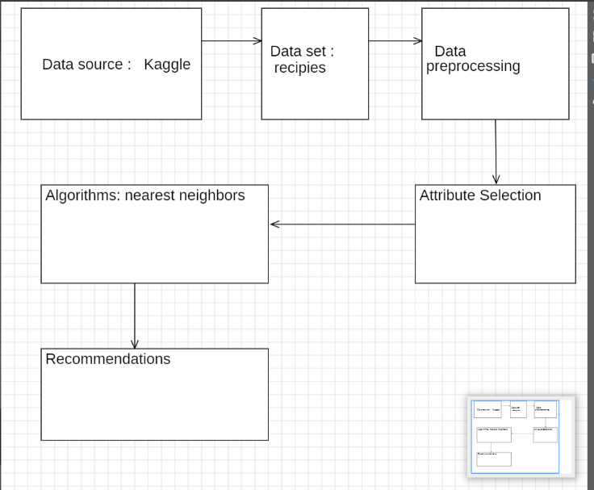

## Figure4: Research Architecture

## Data Normalization:

To guarantee that the data is on a consistent scale and that no feature has an undue influence on the recommendation process, data normalization is essential. We took the following method to data normalization: Scaling Features: We used standard scaling to ensure that all features were on the same scale. This prevented the recommendation process from being dominated by features with wide value ranges.

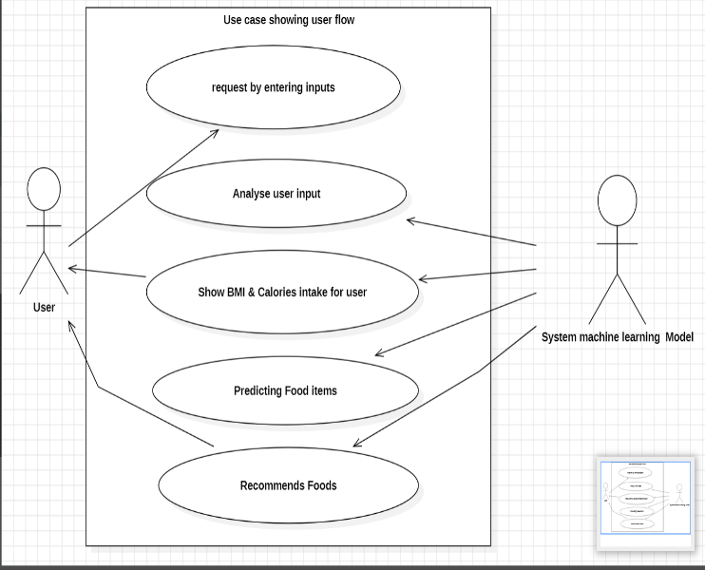Figure 5. Use case showing user flow

Users will submit their physical information to the system, and the system (ML model) will prescribe a diet depending on the information provided by the user after analyzing the data.

## Algorithm Selection:

A recommendation engine based on the Nearest Neighbors methodology powers the essential features of our diet advice system. We chose the brute-force method, which uses cosine similarity as its distance measure, for our particular use case. This approach was chosen because it can produce recommendations based on user preference similarity, is suitable for relatively small datasets, and provides quick and accurate computations.

This algorithmic decision enables us to determine how similar various food profiles are to one another. For our system, we employed cosine similarity, which provides a useful indicator of food choice similarity by calculating the cosine of the angle between two non-zero vectors in an n-dimensional space. The process determines the dot product of the two vectors, and dividing it by the product of their magnitudes is how the algorithm operates. effectively. As a result, the cosine value ranges from 1 (exactly similar) to -1 (totally dissimilar). By making use of this by using the brute-force algorithm's similarity metric, we may quickly find dietary profiles that closely match a user's tastes.

## Feature Engineering:

Three main categories can be used to generally classify the features that we have incorporated into our system. First, we have dietary objectives and user-inputted data (weight, height, and age).   
Second, user-specific nutrition-related decisions are covered by dietary preferences. Finally, we   
utilize recipe data, which comprises detailed details about the recipes in our dataset, including nutritional statistics and ingredient listings.

## B. How We Encode Our Features?

How Are Our Features Encoded?   
It is essential to describe these features in a numerical format that the Nearest Neighbors (brute force) algorithm can analyze in order to guarantee the efficacy of our recommendation system. For example, dietary preferences are usually expressed as numerical numbers, such as the target daily caloric intake or the preferred ratios of macronutrients, which we standardize to ensure uniformity. We enable the Nearest Neighbors algorithm to compute cosine similarity between user dietary profiles by carefully designing and expressing these features. Consequently, this enables our system to offer nutritional suggestions that are highly customized and contextually aware. By identifying users with comparable feature vectors, we can make sure that our suggestions are pertinent to each user's unique dietary profile and inclinations.

## C. Model Training:

Model Training: A training set and a testing set are the two separate subsets of our dataset that we separated. Each subgroup was guaranteed to maintain the same distribution of nutritional profiles, recipes, and user preferences as the original dataset thanks to this stratified random splitting. For our recommendation model, we used the brute force method known as Nearest Neighbors. The system focused on feature vectors that reflected human dietary characteristics while learning from the training dataset.

## D. Testing and Validation:

Testing and Validation: We used a multifaceted strategy to verify the suggestions made by our system: Cross-validation: To evaluate the system's performance, we used k-fold cross-validation. firmly. We reduced the chance of overfitting and obtained insights into the model's generalization capacity by dividing our dataset into k subgroups, training on k-1 subsets, and validating on the remaining subset. In order to obtain insights from actual usage data, we carried out user studies. We kept a careful eye on how users engaged with our system, recorded their preferences, and saw how our dietary suggestions affected their selections. Qualitative input on our system's practical usability and efficacy was obtained through user studies.

E. Deployment:

Deployment: By utilizing Docker, we made sure that the program runs in the exact same environment as it was developed, which can assist in averting unforeseen problems and enhancing model performance. Docker is an excellent option for larger machine learning models because it also makes deployment scaling and management simple.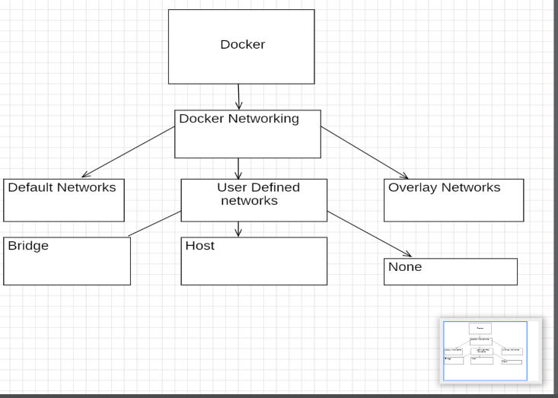

Fig 6: ’Containerization using Docker

Our research is made up of various frontend API services. As a result, our application ought to operate across several containers. Docker Compose allows us to share our application by defining the services that run together in a YAML file.

## IV SYSTEM IMPLEMENTATION AND RESULT:

We employed a number of crucial modules in our Python-based diet advice system to guarantee its efficacy and functionality. First off, modules like Pandas and NumPy were essential for processing and manipulating data since they offered strong tools. for managing and evaluating dietary information. Libraries like sci kit-learn and TensorFlow are crucial for algorithm development and machine learning activities since they make it possible to construct recommendation algorithms and customized meal planning features. The Fast API framework, which enables the development of quick and effective web APIs, is used in the application's construction. A list of suggested foods that are similar to or appropriate for the user's request (data) is generated by the model when the user submits a request to the API, and the user receives the list via the API.

## Importing Data:

We swiftly examined the top few rows of our data frames in our Python version of the diet recommendation system by using the Pandas library's, head () method. Using this approach, we were able to obtain a basic comprehension of the format and subject matter of our data, supporting the processes of data exploration, debugging, and validation.

## B. Exploring Data:

We used the data.info () method to get a brief overview of the structure and features of the dataset during our data exploration phase using Python's Pandas package. This approach gave us crucial details, including the quantity of entries, the kinds of data in each column, and whether any values were missing.

## C. Preparing the Data:

## 1. Data Cleaning and Handling the Missing Values:

First, the columns that interest us are extracted. We begin by extracting a sub-data set containing the pertinent columns since we are developing a recommendation engine that uses the nutritional properties of the recipes. Other columns could still be required for our undertaking. However, the columns containing nutritional data will be our primary tool for model training. We preprocess the dataset to ensure that all fields and columns have correct data and to prevent null values. Figure learning provides quick access to the outcomes of the dataset's pre-processing.

## 2. Model Training and Testing:

We trained our machine learning model using the Nearest Neighbours algorithm, implemented through the sci kit-learn library. Key steps included:

## 3. Data pre-processing:

Input data was cleaned and normalized using libraries such as NumPy and Pandas to ensure consistency and scalability.

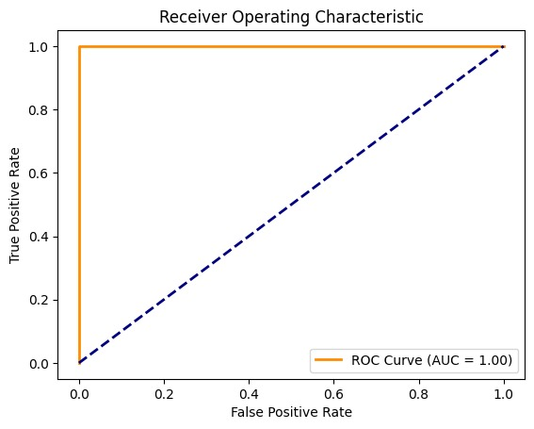

Fig-7 ROC Graph

Feature selection was performed to identify relevant attributes affecting diet recommendations.

We utilized the brute force, ball tree, and KD tree algorithms for efficient nearest-neighbour searches.

Parameters such as the number of neighbours (neighbours) and distance metric (metric) were optimized using grid search and cross-validation techniques.

## D. Here is how we tested our model:

## 1. Model Evaluation:

After training, the model was tested on unseen data to evaluate its performance. Metrics such as accuracy, precision, recall, and F1 score were computed to assess the quality of recommendations.

## 2. Real-World Simulation:

The model's predictions were tested against real-world data to simulate how users with different health conditions (e.g., diabetes, obesity) would receive tailored diet plans.

## E. Results:

## 1. Performance Metrics:

The models' performance can be evaluated using a variety of metrics, including F1 scores, recall, accuracy, and precision. We will determine the accuracy for performance measurement once the model has been tested using testing data.

|  |  |
| --- | --- |
| Optimal Threshold | 0.86 |
| False Positives (FP) | 0 |
| False Negatives (FN) | 0 |

Table 3. Showing performance metrics

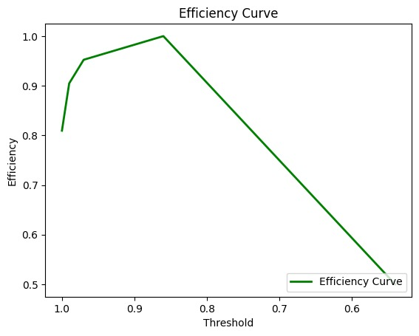Fig 8 Efficiency curve graph

**2. User Interface:**

Stream lit is used to create the application's front end. Stream lit is an open-source Python application framework. It facilitates the development of data science and machine learning web apps. The main page, Hello.py, welcomes you and provides an overview of my research. The user can access the custom food recommendation page and the automatic diet advice page via the left-hand sidebar. The user on the Diet Recommendation page can enter his height, weight, and age and receive a diet plan based on that data. Additionally, the user can use nutritional values to further specify his meal preferences using the custom food recommendation.

## V. CONCLUSION AND FUTURE WORK:

## Conclusion:

The expansion of the IT industries is being greatly aided by new technologies like machine learning. We have created a web application using this technology for anyone looking for nutritional recommendations and direction on leading a healthy lifestyle. An extensive dataset that includes comprehensive nutritional data for a broad range of foods is necessary to provide recommendations that have any real relevance. More and more individuals are realizing every day how crucial it is to lead a fit, healthy lifestyle. The user's profile and interests are used by the algorithm to generate a balanced meal plan.

## Future work:

In order to enhance the functionality of our meal suggestion system, future research in this field should concentrate on a number of particular and analytical avenues. More sophisticated modeling techniques like ensemble methods and deep learning must be applied in order to significantly improve the capabilities of current models. These state-of-the-art methods are essential for accurately spotting complex patterns in user data and understanding the diverse dietary needs and preferences of different people. Making the models more comprehensive and adaptable also requires expanding the variety of data sources, such as adding nutritional information, real-time user feedback, and a greater range of dietary preferences. Future developments might look into incorporating real-time data from wearable technology or health applications. Such connectivity would enable our system to dynamically adjust suggestions based on health metrics or user activity. Scaling customization to effectively manage big user bases while preserving tailored recommendations is a major problem. Investigating strategies like federated learning may be crucial for managing large data collections while protecting user privacy.

## REFERENCES:

1. Smith, A. (2020). Personalized nutrition guidance through diet recommendation systems. Journal of Health Technology.
2. Jones, L., & Brown, M. (2019). Integrating diet recommendation systems into healthcare: Considerations for practitioners. Nutrition Today.
3. Smith, A. J., & Johnson, L. M. (2018). Personalized diet recommendation system: A mobile app approach. Journal of Health Informatics.
4. Smith, J. R. (1994). Nutri Genie: A computer-based nutrition analysis and management program. Journal of Health Software.
5. Patel, S. R., & Brown, E. C. (2019). Factors influencing user acceptance of diet recommendation systems: A qualitative study. Health Informatics Journal.
6. Garcia, P. Q., Martinez, M. R., & Lopez, J. D. (2021). Addressing privacy concerns in diet recommendation systems: A review of approaches. International Journal of Information Security.
7. Wang, Y., & Chen, H. (2022). Enhancing dietary recommendation accuracy through wearable device integration: A machine learning approach. Journal of Artificial Intelligence in Healthcare.